MAYUR JAGTAP

sENIOR SOFTWARE ENGINNER

**DOCKER**

**Docker Installation & command Operations**

1. Create Ubuntu 16.04 machine
2. Login to instance as sudo user:

**sudo su –**



1. **Install Docker on machine** 🡪

Steps: -

1. Install Necessary certificate required for Docker: -

**sudo apt-get install apt-transport-https ca-certificates curl software-properties-common**

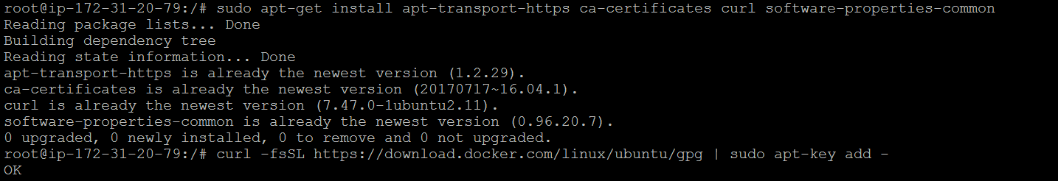

1. Download Key and add to your machine: -

**curl -fsSL https://download.docker.com/linux/ubuntu/gpg | sudo apt-key add –**

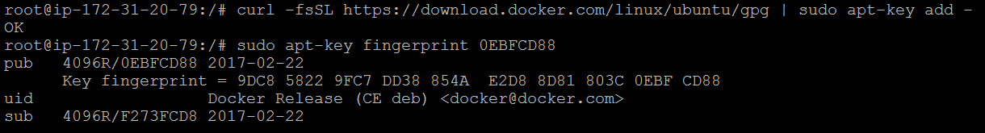

1. Add fingerprint to Docker of Ubuntu 16.04: -

**sudo apt-key fingerprint 0EBFCD88**

**0EBFCD88 🡪 Is default key for Ubuntu 16.04**

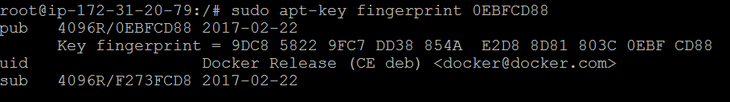

1. Add Docker Repository to machine for future upload & download of images/containers: -

**sudo add-apt-repository "deb [arch=amd64] https://download.docker.com/linux/ubuntu $(lsb_release -cs) stable"**



1. Update Ubuntu 16.04 to latest version: -

**sudo apt-get update**

1. Now install Docker on machine: -

**sudo apt-get install docker-ce**

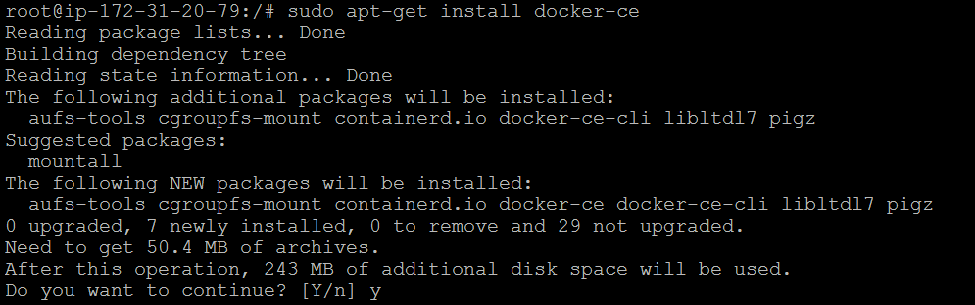

1. Check Docker Version on machine: -

**docker –version**



1. Check Docker status: -

**Service docker status**

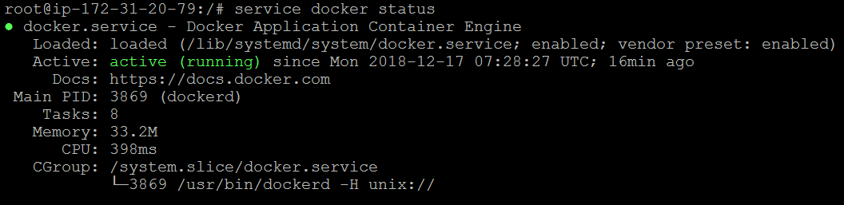

1. **How to pull image from Docker Repository**: -

* Let’s pull fedora image from Repo.

**docker pull fedora**

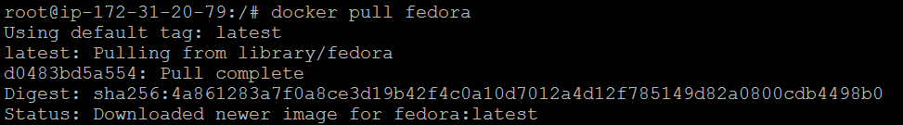

* Now check the image status

**Docker images**



* Now Run Hello World images from Repo: -

**docker run hello-world**

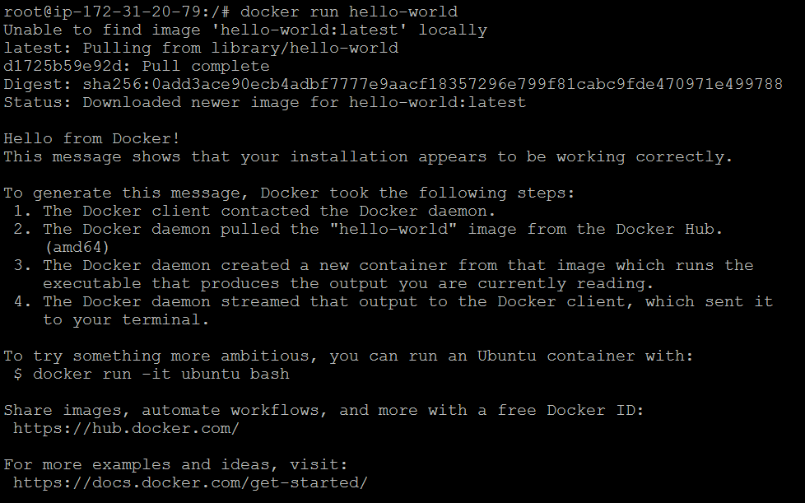



* **In Docker there are three type of image operations**: -
* **Foreground**: Image is running upfront when user/client exit from docker mode it will kill automatically.
* **Background**: Image is running in background when user/client exit from docker mode it will still running, user/client need to kill manually to stop the image.
* **Interactive**: Image is running in background when user/client exit from docker mode it will still running, user/client need to kill manually to stop the image.
* Let’s run Ubuntu 14.04 image from Repo in background mode

**docker run -d ubuntu:14.04 /bin/sh -c "while true; do echo hello world; sleep 1; done"**

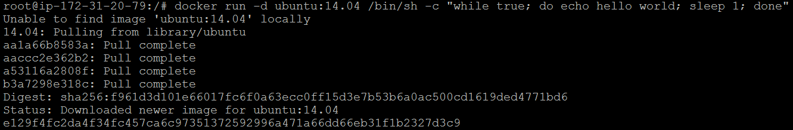

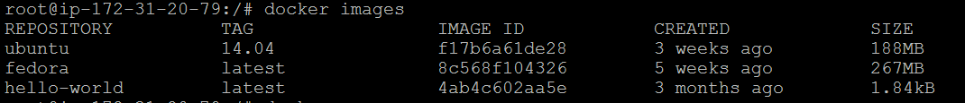

* Now let’s execute the Ubuntu 14.04 container in interactive mode: -

1. To find container ID: -

**docker ps**



1. Now execute the container with container ID: -

**docker exec -it e129f4fc2da4 /bin/bash**



1. Now you are in Docker Client command prompt: -



1. To check the status of container, login to new session as root user and run below command: -

**docker ps**



1. To Exit from Docker Client mode, press **CLT + D** to get out of it.
2. Now to stop the running container: -

**Docker stop e129f4fc2da4**



1. Check the status of container: -



There is no active container or no running container.

1. To check the available container on machine: -

**docker ps -a**



1. To get available docker container ID: -

**Docker ps -aq**

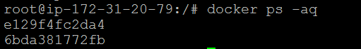

1. To check logs of container: -

**Docker logs 6bda381772fb**

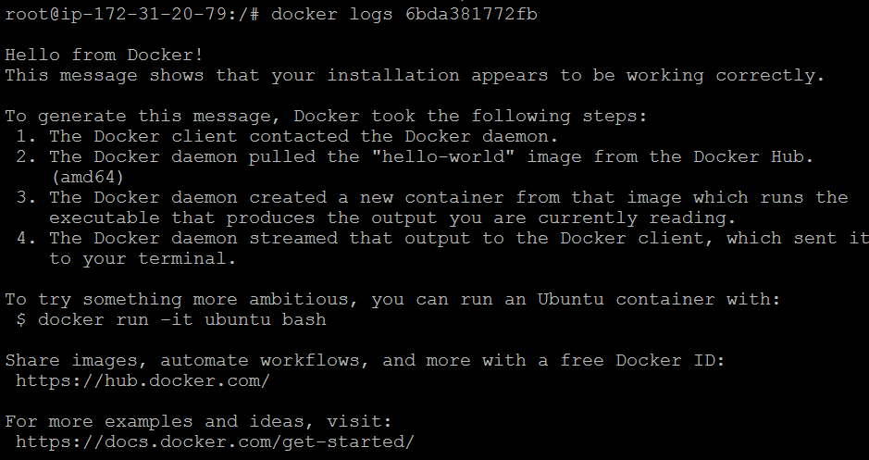

1. To remove image from machine: -

**docker rm (container ID)**

1. To remove images from container whose status is “Exited”: -

**docker rm $(docker ps -aq --filter "status=exited")**



**docker ps -a**



Now there are no active available or running container on machine

1. **Hot to create image from running container**: -

**docker run -i -t fedora /bin/bash**

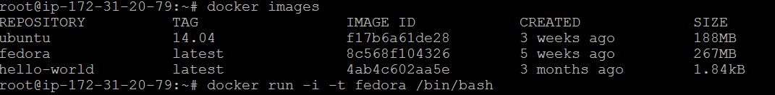

1. Now install latest **httpd** update for fedora: -

**yum install httpd**



1. Now use new session to get container ID: -

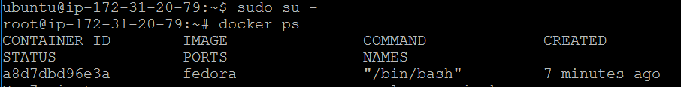

1. Now run below command in new session to get image of running container with name “**mj/fedora:httpd**”

**docker commit -a "Mayur Jagtap" -m "Fedora with HTTPD package" a8d7dbd96e3a mj/fedora:httpd**



1. Now run created image: -

**docker run -i -t mj/fedora:httpd**



1. Check the status of created image: -

